 |  |  | LASFAA Fall 2020 Virtual Conference
Date | Time | Session Title | Session Speaker | Unique Registration List
10/19/2020 | 10:00-11:30 | Welcome and NASFAA Update | Alan Jackson/Brad Meyers and Brenda Hicks
10/19/2020 | 11:30-12:00 | SWASFAA Update | Mendy Schmerer
10/20/2020 | 10:00-11:30 | Federal Update | Webb, Nautochia
10/20/2020 | 2:00-3:00 | Session: COVID and Working Remote Best Practices | Panel **
10/21/2020 | 10:00-11:30 | Session: Verification 2021 | Webb, Nautochia
10/21/2020 | 2:00-3:00 | Session: Diversity and Inclusion in Financial Aid | Brittany Williams
10/22/2020 | 10:00-11:00 | Session: Financial Aid Support & Retention: What are we doing to support retention of students through Financial Aid | Panel***
10/22/2020 | 2:00-2:15 | Vendor/Sponsor Mini Session | Sponsor/Vendor
10/22/2020 | 2:15-2:30 | Vendor/Sponsor Mini Session | Sponsor/Vendor
10/22/2020 | 2:30-2:45 | Vendor/Sponsor Mini Session | Sponsor/Vendor
10/22/2020 | 2:45-3:00 | Vendor/Sponsor Mini Session | Sponsor/Vendor
10/22/2020 | 6:00 | Zoom Social Update (find a game to play) | LASFAA Board and LASFAA Membership and Sponsors
10/23/2020 | 9:00:00-10:00 | Session LOSFA | Deborah Paul
10/23/2020 | 10:00-11:00 | Annual Business Meeting | LASFAA Board and LASFAA Membership
10/23/2020 | 10:00-11:00 | Closing Session: Thank you to membership (with slideshow), passing of the gavel | LASFAA Board and LASFAA Membership

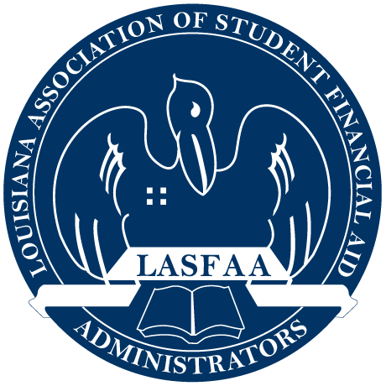 Virtual Giftcards- done/ Game for social ; barriers to entry; spirit days/contest / themes for the day/panel/put time between the sessions/panel/moderator/ask lynette about zoom rooms

